Brunel 200 arts projects announced

Embargoed to 00.01 Thursday 29 September 2005

Twenty-nine arts projects celebrating the life and work of Isambard Kingdom Brunel were announced today. Ranging from a new play about Brunel to be performed in schools, through to a drama project involving black elders talking about the meaning of Brunel’s work for them, each project joins the massive programme of celebration in Bristol for the bicentenary of Brunel’s birth that will take place in 2006.

Andrew Kelly, director of Brunel 200, said today:

‘Brunel was an artist, designer and architect as well as an engineer. He was a patron of the arts. We decided to launch a fund to challenge artists today to come up with new projects that celebrate his life and work. We wanted original projects, that were of outstanding artistic quality, and that took the Brunel message to the widest range of people.’

Over 70 proposals were put forward to the £180,000 fund. Projects funded include:

- David White, a photographer who has worked for Marie Clare, will recreate the camera with which Robert Howlett took the classic photograph of Brunel in front of the chains to take 20 classic shots of Brunel projects now.
- Andrew Taylor, best-selling crime novelist (and Richard & Judy shortlisted author) will write a five-part drama set in a Brunel project which will be serialised daily in local newspapers and published as a book to be distributed to the 500 delegates to the Left Coast Crime convention that takes place in Bristol in March 2006.
- Artist Glen Eastman will work with 10 schools to create a soft sculpture of the famous chains for display.
- The Hotwells’ Community Association will launch a competition to find a new use for the stovepipe hat.
- Luke Jerram, a NESTA fellow, will recreate the sound of Brunel’s atmospheric train in a disused tunnel in Bristol.
- Nick Hand will interview and photograph representatives of all the companies that have Brunel in their name today – from Brunel’s Buttery, the much-loved sandwich bar in the docks, to Brunel Ford, the leading car sales company.

These are joined by projects at Temple Meads, including a massive mural of Brunel’s life and work, and projects on the trains between Bristol and London. One project from Paralalia, has a Flash Gordon type Isambard many centuries in the future solving problems in the spirit of his forebear.

Simon Cook, chairman of Bristol Cultural Development Partnership, the body responsible for Brunel 200, said:

‘We were delighted with the projects put forward. The spirit and vision of Brunel remains ever present in Bristol. I can’t wait to see these projects which are going to be part of a wonderful year for the city.’

A full list of the arts projects is attached.

ENDS

Contacts
Andrew Kelly +44 (0)1275 370816
Mobile: 07778 932 778
andrew.kelly@businesswest.co.uk

Melanie Kelly +44 (0) 1225 470180
brunel200@btopenworld.com.

Brunel 200 is an initiative of Bristol Cultural Development Partnership
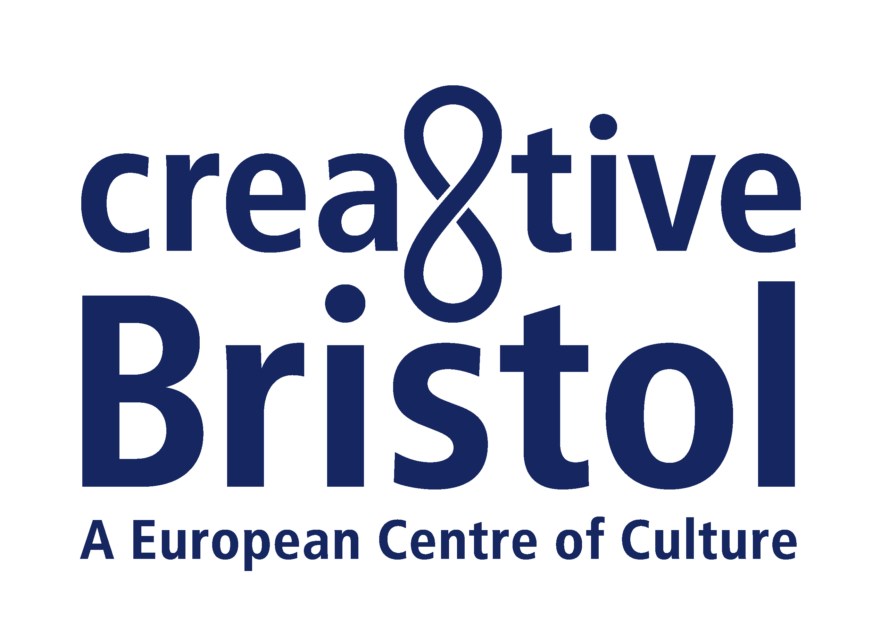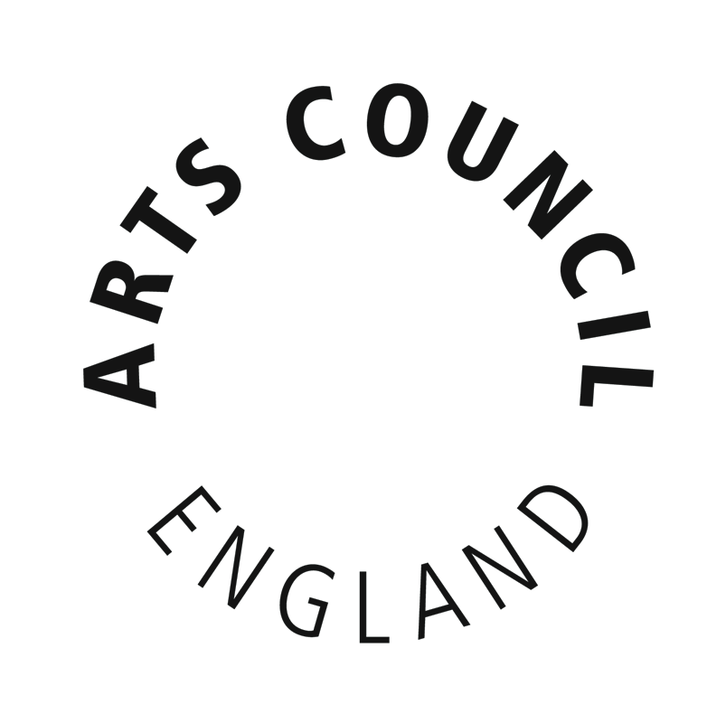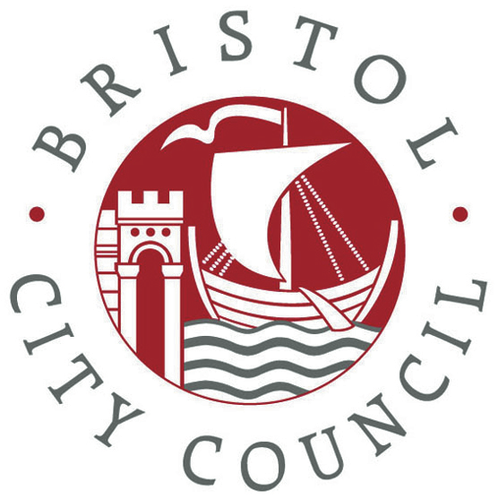

NOTES TO EDITORS

Brunel 200
Brunel 200 is responsible for the overall 2006 celebrations. It is an initiative of Bristol Cultural Development Partnership (BCDP). BCDP is a partnership of Arts Council England South West, Bristol City Council and Business West. It promotes long-term cultural development in Bristol. Projects include: At-Bristol, Brief Encounters Short Film Festival, Animated Encounters, Bristol Legible City, the new Bristol Festival of Ideas, and the annual Great Reading Adventure, when everyone is encouraged to read the same book at the same time. BCDP led Bristol’s short listed bid to be European Capital of Culture in 2008. As a result of this work, Bristol was designated one of five British Centres of Culture. Creative Bristol is the name given to the initiative that aims to deliver as much of the proposed 2008 programme as possible. Brunel 200 is part of that programme.
Brunel 200 is funded by Arts Council England South West, Bristol City Council and Business West. It is supported by funding from the National Lottery, including over £500,000 from the Urban Cultural Programme (Arts Council England and the Millennium Commission) and a grant of £980,000 from the Heritage Lottery Fund.
The Brunel 200 website at www.brunel200.com includes extensive background information about Brunel as well as news of activities planned for the celebrations.

Highlights of the Brunel 200 activities include:

- On Brunel’s birthday weekend, 8-9 April 2006, there will be a procession and street party culminating in the switching on of the new lighting scheme at the Clifton Suspension Bridge.
- Major exhibitions at ss Great Britain, At-Bristol and the City Museum and Art Gallery covering the story of Brunel’s life and work, the science and engineering of Brunel, and the art of the industrial age.
- Free distribution of 100,000 copies of a 96pp graphic biography of Brunel’s life and work for readers aged 11 and upwards. Other publications include The Brunel Book, with 16 newly commissioned essays and 250 illustrations.
- Massive education programme ensuring that every school child in Bristol will be able to learn about Brunel, visit the exhibitions and Brunel attractions. Other educational projects include reopening the competition to design the Clifton Suspension Bridge for schools; work to encourage more people – and especially women – to go into engineering; and the placing of 400 artists, scientists and engineers in residence.
- A re-creation of the Royal Dinner of 1843, which launched the ss Great Britain.
- Bristol’s annual Great Reading Adventure in which everyone will be encouraged to read Around the World in Eighty Days, chosen because of its Victorian theme of optimism as well as because Jules Verne, its author, sailed on Brunel’s ship, the ss Great Eastern. This will become a South West regional project for 2006 as part of the Brunel 200 celebrations. It is anticipated that 100,000 people at least will participate.
- Widespread promotion of engineering, architecture, design and the arts.

