

Huge Boost for Brunel 200 as Heritage Lottery Fund invests £1 million

Embargoed to 00.01 Thursday 23 June 2005

Bristol’s ambitious plans for a year long celebration of the life and work of Isambard Kingdom Brunel in 2006 took a huge step forward today with the award of £980,000 from the Heritage Lottery Fund (HLF).

The Brunel 200 programme celebrates Brunel’s life, times and legacy and includes exhibitions, educational projects, publications and arts projects, which will take place throughout Bristol and the South West. Brunel 200 will also provide the lead for a series of national celebrations, making links with activities taking place across the country, including Brunel associated sites in London, South Wales and Portsmouth.

Leslie Perrin, Chairman of Brunel 200, commented today:

‘I am delighted at this award. We are passionately committed to making Brunel 200 a celebration that reaches everyone in Bristol and the South West, and this fantastic support from the Heritage Lottery Funds means that we can produce bigger and better exhibitions and education projects.’

Many of the Brunel 200 events in Bristol will be centred on some of Brunel’s finest achievements for the city, including the Great Western Railway, Clifton Suspension Bridge and ss Great Britain.

The HLF award comes on top of investment made already by the Millennium Commission and Arts Council England lottery fund. It provides support for, among other projects, exhibitions, education, and the 2006 South West Great Reading Adventure which encourages everyone to read the same book at the same time. The total budget, once private sector sponsorship has been added, now stands at £2,200,000.

Nerys Watts, South West Manager of the Heritage Lottery Fund said:

‘Over the last ten years HLF has put almost £300 million into a huge range of projects in the South West, and Brunel 200 is one of the most dynamic and innovative schemes that I have seen in that time. It will raise the profile of local heritage with people in Bristol and beyond, and really emphasise the continued importance of Brunel’s legacy in the contemporary environment.’

In addition to the budget for the Brunel 200 programme, another £15m is being invested in the Bristol Brunel sites with a new visitor centre at the Clifton Suspension Bridge, a renewed ss Great Britain, and the digitisation of a significant part of the Brunel archive at the University of Bristol.

Simon Cook, chair of Bristol Cultural Development Partnership, which manages Brunel 200, concluded:

‘Brunel was the greatest engineer of the nineteenth century and remains an inspiration today. Brunel 200 was always a key part of our 2008 Capital of Culture bid. When we did not win the 2008 award, we said that we would deliver anyway. Brunel 200 shows that we are keeping this promise and it will be a great addition to the region’s cultural calendar.’

For further information, please visit the Brunel 200 website at www.brunel200.com.

ENDS

Contacts

Andrew Kelly +44 (0)1275 370816
andrew@brunel200.com

Melanie Kelly +44 (0) 1225 470 180
melanie@brunel200.com

Leslie Perrin +44 (0) 117 917 4326
leslie.perrin@brunel200.com

Simon Cook +44 (0) 117 973 2138
Mobile: 07802 728422
simon_cook@bristol-city.gov.uk

Brunel 200 is an initiative of Bristol Cultural Development Partnership
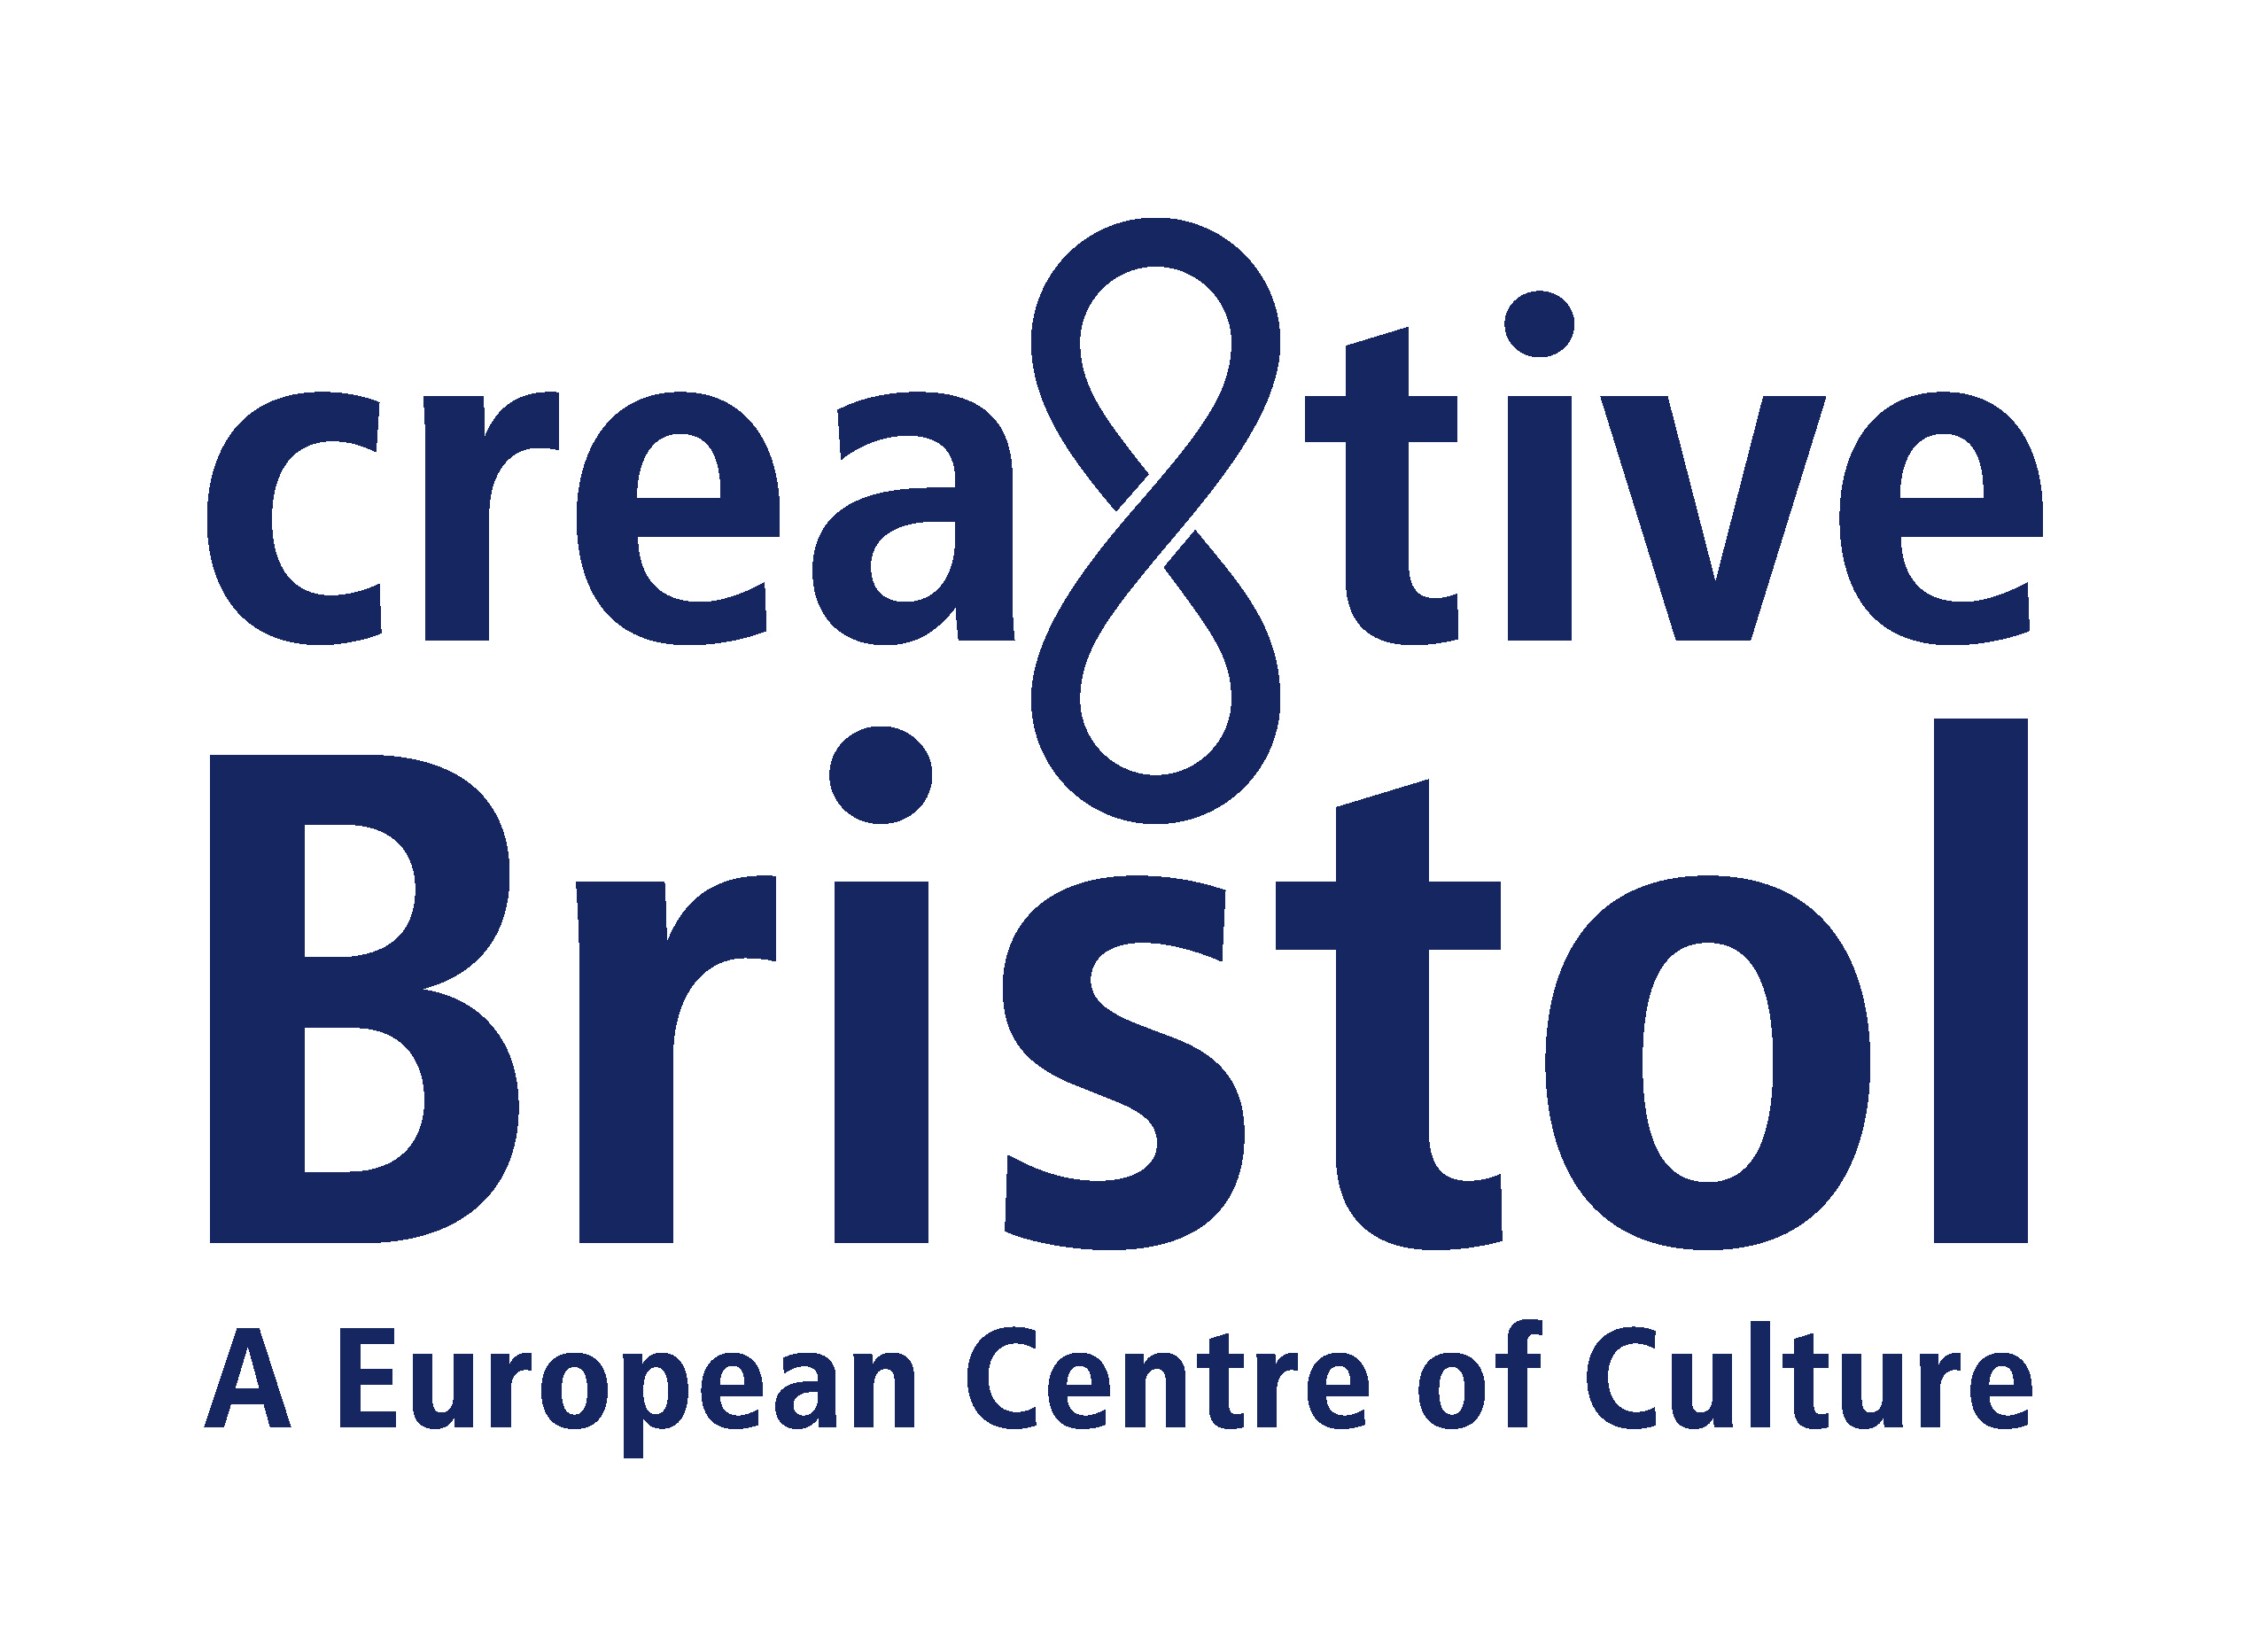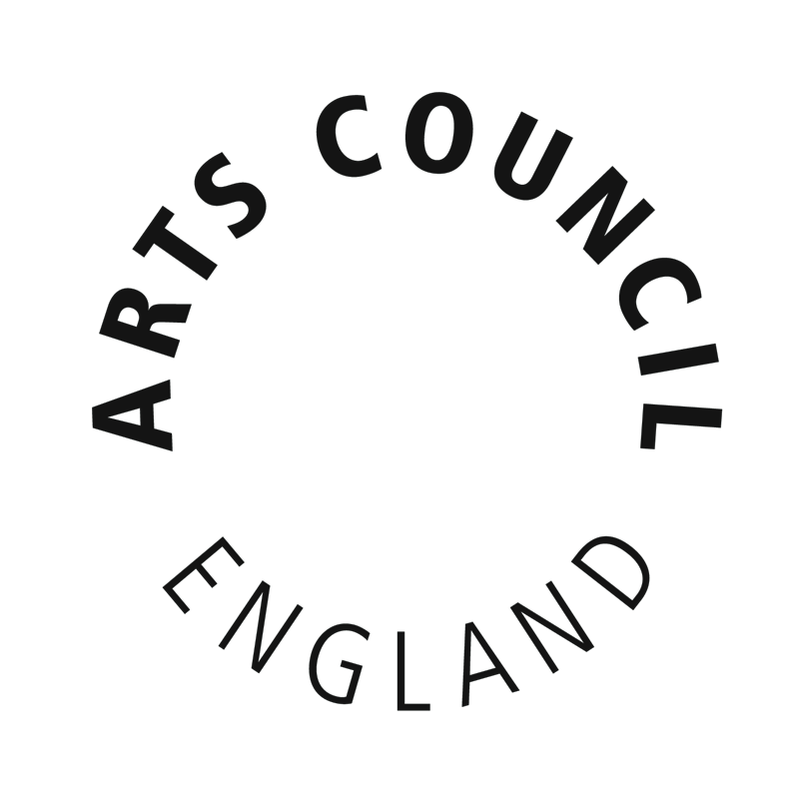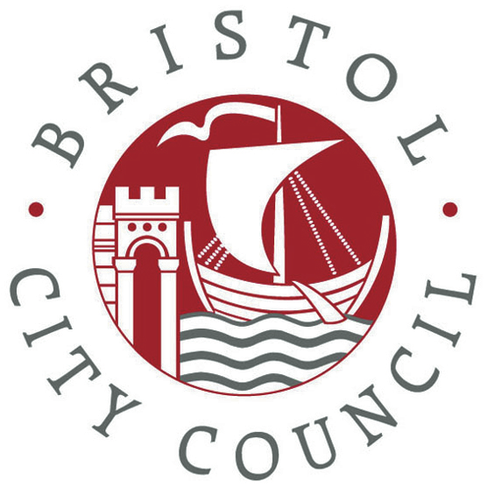


NOTES TO EDITORS

Brunel 200
Brunel 200 is responsible for the overall 2006 celebrations. It is an initiative of Bristol Cultural Development Partnership (BCDP). BCDP is a partnership of Arts Council England South West, Bristol City Council and Business West. It promotes long-term cultural development in Bristol. Projects include: At-Bristol, Brief Encounters Short Film Festival, Animated Encounters, Bristol Legible City, the new Bristol Festival of Ideas, and the annual Great Reading Adventure, when everyone is encouraged to read the same book at the same time. BCDP led Bristol’s short listed bid to be European Capital of Culture in 2008. As a result of this work, Bristol was designated one of five British Centres of Culture. Creative Bristol is the name given to the initiative that aims to deliver as much of the proposed 2008 programme as possible. Brunel 200 is part of that programme.

Andrew Kelly is Director of Brunel 200 and Bristol Cultural Development Partnership.
Brunel 200 is funded by Arts Council England South West, Bristol City Council and Business West. It is supported by funding from the National Lottery, including nearly £600,000 from the Urban Cultural Programme (Arts Council England and the Millennium Commission) and £980,000 from the Heritage Lottery Fund.
The Brunel 200 website at http://www.brunel200.com includes extensive background information about Brunel as well as news of activities planned for the celebrations.

Brunel 200 South West
Brunel 200 South West, a joint initiative of Bristol Cultural Development Partnership and Culture South West, will create, co-ordinate, market and promote regional activity outside of Bristol. It aims to bring together regional agencies and the cities, towns and communities touched by Brunel. Potential areas of activity for Brunel 200 events include the Swindon Railway Village and Works, Bath, Newton Abbot (site of Brunel’s atmospheric railway trials), Torbay (proposed site of his retirement home) and the Royal Albert Bridge at Saltash. Martyn Heighton is the Brunel 200 South West Champion, responsible for the bicentenary celebrations in the rest of the region. An audit of Brunel 200 South West is available on the Brunel 200 website and also at Culture South West - http://www.culturesouthwest.org.uk/.

Highlights of the Brunel 200 activities in Bristol include:

- On Brunel’s birthday weekend, 8-9 April 2006, there will be a procession and street party culminating in the switching on of the new lighting scheme at the Clifton Suspension Bridge.
- Major exhibitions at ss Great Britain, At-Bristol and the City Museum and Art Gallery covering the story of Brunel’s life and work, the science and engineering of Brunel, and the art of the industrial age.
- Free distribution of 100,000 copies of a 96pp graphic biography of Brunel’s life and work for readers aged 11 and upwards. Other publications include Brunel: ‘in love with the impossible’, with 16 newly commissioned essays and 250 illustrations.
- Bristol’s annual Great Reading Adventure in which everyone will be encouraged to read Around the World in 80 Days, chosen because of its Victorian theme of optimism as well as because Jules Verne, its author, sailed on Brunel’s ship, the ss Great Eastern. This will become a South West regional project for 2006 as part of the Brunel 200 celebrations. Over 100,000 people are likely to take part. See www.bristolreads.com for further information.
- Massive education programme ensuring that every school child in Bristol will be able to learn about Brunel, visit the exhibitions and Brunel attractions. Other educational projects include reopening the competition to design the Clifton Suspension Bridge for schools; work to encourage more people – and especially women – to go into engineering; and the placing of 400 artists, scientists and engineers in residence.
- A recreation of the Royal Dinner of 1843, which launched the ss Great Britain.
- A Brunel 200 ball.
- Widespread promotion of engineering, architecture, design and the arts.

There will also be a programme of arts projects to be announced in September.

BRUNEL BIOGRAPHY

Isambard Kingdom Brunel was born in Portsea, Portsmouth on 9 April 1806. His father, Marc Isambard Brunel, was a French royalist who had fled France in 1793 during the Reign of Terror and was knighted in 1841 for his contribution to British engineering.

Brunel travelled to France in 1820 to study engineering at the College of Caen in Normandy and the Lycée Henri Quatre in Paris. He also served an apprenticeship with Abraham Louis Breguet, a master-craftsman skilled in the making of watches and scientific instruments. He returned to Britain in August 1822 and joined his father’s drawing office.

Brunel was formally appointed the resident engineer of his father’s project to build a tunnel beneath the Thames in January 1827. Despite his youth and lack of experience, he gained the respect of his men through his dedication, hard work and bravery. After many years delay the Thames Tunnel was eventually opened to foot traffic on 25 March 1843. It was the first tunnel to be built under a navigable river and was hailed as the eighth wonder of the world. In 1869, it was converted to carry the East London Railway. Today around 14 million train passengers travel through it each year.

In January 1828 Brunel was seriously injured during a major flood at the tunnel. He spent part of his convalescence in Bristol, where he heard of plans to build a bridge across the Avon at Clifton. In March 1831, one of Brunel’s designs submitted for the Clifton Suspension Bridge competition was formally awarded first prize and a ceremony to mark the laying of the bridge’s foundation stone took place on 21 June. The Clifton Suspension Bridge was not completed until 1864, built as a tribute by his fellow engineers to Brunel who had died five years earlier. Although built for pedestrian and horse drawn traffic, the bridge was so ingeniously constructed that it is now capable of carrying around 4 million cars a year, and has become a major route to the region’s motorway network. It is also a structure of great beauty.

In 1832 Brunel began his association with the Bristol Docks Company where he was engaged with schemes for improving and modernising the facilities for the next 15 years. He worked at other docks during his career including Plymouth, Cardiff and Milford Haven.

In March 1833 Brunel was appointed chief engineer of the newly formed Great Western Railway (GWR) and started surveying the route from London to Bristol. He would go on to hold engineering appointments with many other railway companies in the coming years, including supervising projects in Italy and India. He was usually involved in every detail of their construction: not only devising the route, track, carriages and engines, but also the architecture of the stations, the colour of the livery and the decorative details on the lamp posts. The London-Bristol section of the GWR was opened on 30 June 1841 and is the subject of an application for World Heritage Status.

In 1836 Brunel was appointed engineer of the Great Western Steamship Company and work began in Bristol on his first ship design, ss Great Western. She was an oak-hulled paddle steamer and the first steamship to provide a regular trans-Atlantic service, heralding a new era of ocean going transport. Construction began on her sister ship, the ss Great Britain, in 1839 at the Great Western Dockyard. She was the largest and most powerful ship to have been built to date and the first propeller driven, steam powered iron ship to cross the Atlantic. The ss Great Britain is the forerunner of modern passenger liners, and made regular voyages carrying thousands of passengers to the USA and Australia. Following her distinguished but occasionally ill-fated career, she returned to Bristol in 1970 from the Falklands and now is one of the major tourist attractions in the city. A £11m lottery funded restoration programme is due for completion in 2005.

In 1853 work began on Brunel’s most ambitious maritime project: the ss Great Eastern. She was conceived as the biggest steamship yet to be built, one that would be capable of carrying 4,000 passengers at a time on a non-stop trip to Australia. The ss Great Eastern proved uneconomic as a passenger ship but had a new lease of life when she was used to lay the first successful trans-Atlantic telegraph cable.

During this period, in addition to his numerous railway projects, Brunel was also working on the construction of his final engineering triumph, the Royal Albert Bridge at Saltash, and devising a pre-fabricated hospital for the Crimea.

Brunel collapsed on 5 September 1859 during preparations for the sea trials of the ss Great Eastern. He died at his Westminster home ten days later and was buried in Kensal Green Cemetery on 20 September 1859.

