BRUNEL 200 PRESS RELEASE/ PHOTO OPPORTUNITY
Super Hero Engineer Lands in Comic Store

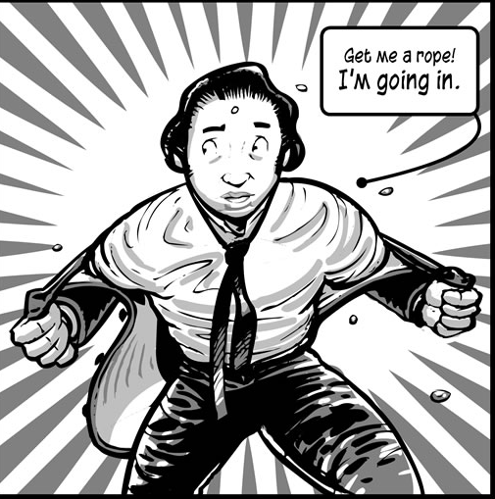
For immediate release

In the run-up to the Brunel 200 birthday weekend celebrations, Bristol comic book store Travelling Man is helping to launch a new 100-page graphic biography of Isambard Kingdom Brunel on 5 April 2006.

Described as ‘A STEAM POWERED FEAST of ENTERTAINMENT brought to you through the MIRACLE of modern precision-engineered CARTOONS’, the comic has been designed and illustrated by local artist Simon Gurr, with text by writer and journalist Eugene Byrne.

Simon said today that Brunel’s ‘amazing drive and energy, his enduring popularity and most importantly for me as an artist, his incredibly distinctive appearance, made him an ideal subject for a comic.’

He continued: ‘A comic about a great man’s very interesting life story which also delivered some useful facts about science and history seemed like a winner to me!’

The comic is aimed at readers aged 11 and over, and tells the story of Brunel and the world in which he worked as well as demonstrating clearly and simply the engineering techniques and scientific principles underlying his creations.

Over 135,000 copies have been printed by Brunel 200, most of which will be given away free through schools, colleges, exhibition sites and libraries in Bristol and the rest of the South West.

Eugene Byrne said of the comic’s hero:

The thing that really comes across when you spend any time studying Brunel is the man’s sheer ruthlessness. None of this makes Brunel a bad person as such. He was simply a driven individual who was himself one of the casualties of his ambition, dying at a young age partly as a result of overwork.

He went on:

It’s important, I think, to realise that there was much, much more to his talents than engineering. If his gift had merely been for building bridges and railways he would now be an obscure footnote in history books. What he also had going for him was a huge charisma and superb powers of persuasion. He was not some dull dusty guy with a slide-rule, he was a great showman.

Andrew Kelly, director of Brunel 200, said:

This wonderful comic will prove a great success, we are sure, with younger readers. It’s got romance, danger, riots, explosions, drama – as well as cigars and tall hats – and should really capture their imagination.

Copies of the comic are available to members of the public, while stocks last at Blackwell, Park Street, Bristol, Travelling Man, Park Street, Bristol and Secession Books, Trim Street, Bath. For monitoring purposes, postcode details will be requested from those who receive a copy of the comic.

ENDS

Contacts

Photo Opportunity: Simon Gurr and Eugene Byrne at the Travelling Man, 8 Park Street, Bristol, Wednesday 5 April, 10.30am.

Contact Melanie Kelly on brunel200@btopenworld.com if you wish to attend.

At the top of this release is a low-resolution version of an image from the comic – high-resolution versions of this and other pages and promotional material from the comic available as above. Copies of the comic can also be posted on request.

NOTES TO EDITORS

Brunel 200
Brunel 200 is responsible for the overall 2006 celebrations. It is an initiative of Bristol Cultural Development Partnership (BCDP). BCDP is a partnership of Arts Council England South West, Bristol City Council and Business West. It promotes long-term cultural development in Bristol. Projects include: At-Bristol, Brief Encounters Short Film Festival, Animated Encounters, Bristol Legible City, the new Bristol Festival of Ideas, and the annual Great Reading Adventure, when everyone is encouraged to read the same book at the same time. BCDP led Bristol’s short listed bid to be European Capital of Culture in 2008. As a result of this work, Bristol was designated one of five British Centres of Culture and made the commitment to deliver as much of the programme in the bid as possible.

Brunel 200 is funded by Arts Council England South West, Bristol City Council and Business West. It is supported by funding from the National Lottery, including over £500,000 from the Urban Cultural Programme (Arts Council England and the Millennium Commission) and a grant of £1,500,000 from the Heritage Lottery Fund.

Key sponsors include Discovery Channel, First Great Western, Osborne Clarke and Bond Pearce.

The Brunel 200 website at www.brunel200.com includes extensive background information about Brunel as well as news of activities planned for the celebrations.

Highlights of the Brunel 200 activities include:
- On Brunel’s birthday weekend, 8-9 April 2006, there will be a performances and entertainment culminating in the switching on of the new lighting scheme at the Clifton Suspension Bridge.
- Major exhibitions at ss Great Britain, At-Bristol and the City Museum and Art Gallery covering the story of Brunel’s life and work, the science and engineering of Brunel, and the art of the industrial age.
- Free distribution of over 135,000 copies of a graphic biography of Brunel’s life and work for readers aged 11 and upwards. Other publications include Brunel: in love with the impossible, with newly commissioned essays and over 460 illustrations.
- Extensive education programme ensuring that every school child in Bristol will be able to learn about Brunel, visit the exhibitions and Brunel attractions. Other educational projects include reopening the competition to design the Clifton Suspension Bridge for schools and engineers; work to encourage more people – and especially women – to go into engineering; and the placing of 400 artists, scientists and engineers in residence.
- A re-creation of the Royal Dinner of 1843, which launched the ss Great Britain.
- Bristol’s annual Great Reading Adventure in which everyone was encouraged to read Around the World in Eighty Days, chosen because of its Victorian theme of opening up the world through transport and technology as well as because Jules Verne, its author, sailed on Brunel’s ship, the ss Great Eastern. This became a South West regional project for 2006 as part of the Brunel 200 celebrations. It is anticipated that 100,000 people at least participated.
- Wide-ranging activity throughout the South West from Swindon to Penzance, including the July Swindon Brunel Festival.

