

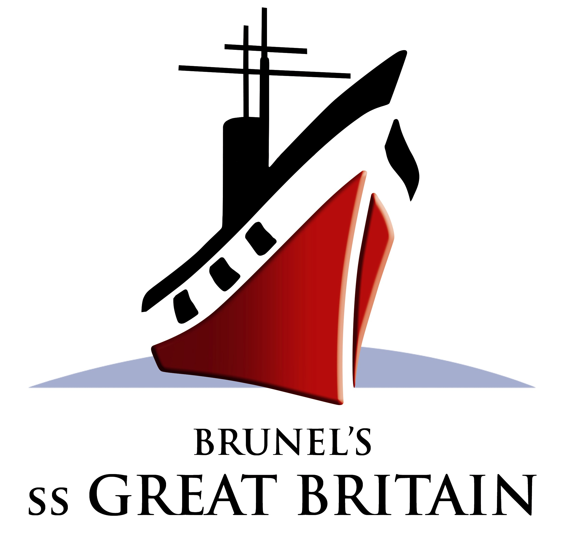

Modern Voyages: Sea Travel since Brunel

An interdisciplinary conference at the ss Great Britain
Thursday 20 and Friday 21 April 2006

Call for Papers

The inventiveness of Brunel and his contemporaries meant the nineteenth century witnessed unprecedented transformations in the methods and experiences of sea travel. This conference will be interdisciplinary in approach, bringing together speakers from the world of cultural and historical enquiry with engineers and designers to consider the importance of sea travel in shaping the modern world. A range of sessions will examine the historical realities of these changes, their representation in visual and literary culture and their legacy from the 1840s to today.

Possible session strands might include:
- What were the principal innovations in maritime engineering between Brunel’s ss Great Britain and the relaunch of the QE2?
- How have these developments changed the actual experience of sea travel?
- What new discoveries has modern sea travel facilitated and what impact have they had upon culture, society, and science?
- How were new ships and lines celebrated and launched?
- What memorials, (monumental sculpture, opera, poetry, film), have naval disasters inspired?
- What influence have new strategies in maritime engineering had upon architecture and design on dry land?
- How have writers, painters and filmmakers portrayed different types of sea travel, such as emigration or deportation, luxury ocean liner travel or military transport?

The intention is to create a publication.

Please send abstracts of paper proposals (300 words) by 1 December 2005 to:

Dr Claire I R O’Mahony
Director of History of Art Lifelong Learning
University of Bristol Department of History of Art
43 Woodland Road Bristol BS8 1UU United Kingdom
0(0 44) 117 331 1197; Claire.OMahony@bristol.ac.uk

This conference is a partnership project organised by University of Bristol History of Art Lifelong Learning and ss Great Britain as part of the Brunel 200 celebrations funded by Arts Council England, the Heritage Lottery Fund and the Millennium Commission. There will be a year-long season of exhibitions and events including: three exhibitions at the The Nine Lives of I K Brunel at the ss Great Britain, Brunel and the Art of Invention at the Bristol City Art Gallery and Museum and The Forces That Made Brunel in @t-Bristol. For further details see www.brunel200.com.

