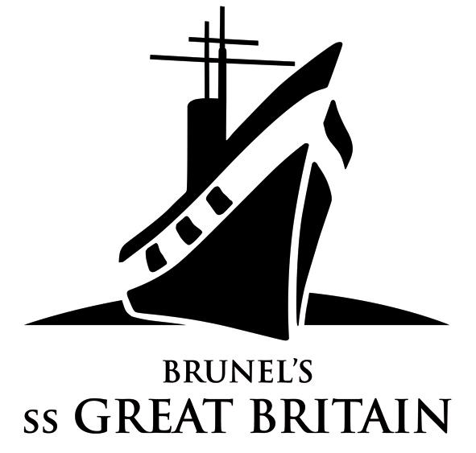

NEWS RELEASE

WORK STARTS ON BRUNEL’S NINE LIVES
For immediate release

WORK has started on the nationally significant exhibition for the Brunel 200 celebrations – ‘The Nine Lives of I.K. Brunel’.

The ss Great Britain Trust has given the go ahead to building contractors John Perkins Construction Ltd for the refit of the Maritime Heritage Centre, beside the ss Great Britain, to provide bespoke exhibition space on the ground floor and improved conference and education facilities on the extended mezzanine level.

The Maritime Heritage Centre, which housed the Trust’s exhibition on the ss Great Britain and the ship’s conservation programme, has stood empty since April 2005.

Now it is being prepared for ‘The Nine Lives of I.K. Brunel’, one of the highlights of the bi-centenary celebrations of the Victorian engineer’s birth in 1806. The exhibition, which focusses on Isambard Kingdom Brunel, the man and engineer, is expected to attract national interest. The exhibition’s title relates to Brunel’s many brushes with death as well as his many financial and engineering successes and failures.* ^{[see Notes to Editors]}

Exhibits on show will include many loaned from museums and collections across the UK. The biggest will be a 50-tonne replica broad gauge locomotive, the ‘Iron Duke’, which has to be transported from the National Railway Museum inYork.

‘The Nine Lives of I.K. Brunel’ will open to the public from April to October, 2006, as a major part of the bi-centenary celebrations of Brunel’s birth. It is also twinned with At- Bristol, which will show ‘The Forces that Made I.K. Brunel’. Funding for both exhibitions has come from the Heritage Lottery Fund, and the Urban Cultural Programme.

The ss Great Britain Trust’s Director Matthew Tanner, commented: “It is wonderful to see the Trust’s plans for an exciting new exhibition on the man who built the ss Great Britain, come to fruition.

“The Trust’s trustees and staff are working closely alongside the partners in Brunel 200 and the Bristol Cultural Development Partnership, to provide visitors to the city with a wealth of opportunities to learn more about the man and his crucial role in Britain’s and the world’s great industrial age. This exhibition and the Brunel 200 celebrations will give Bristolians plenty to do and see throughout 2006, and are also expected to attract visitors to Bristol from across the UK and from abroad.”

The Trust’s Interpretation Manager Dr Kate Rambridge, who is leading on the content for the exhibition, explained: “This exhibition tells some of the lesser-known stories of Isambard Kingdom Brunel. Through his own words, as well as reports from contemporaries, visitors will have the chance to discover who he was, and how he met the challenges and opportunities of engineering in the 19th century.

“We plan to give visitors, even those who know Brunel well, some surprises and offer them new insights into his personal life and his approach at times of professional crisis.”

Nerys Watts, South West Manager of the Heritage Lottery Fund, said: “Brunel 200 is one of the most dynamic and innovative schemes that that HLF has ever supported in the South West. It will raise the profile of local heritage with people in Bristol and beyond, and really emphasise the continued importance of Brunel’s legacy in the contemporary environment.”

Interest in Brunel has been fuelled by the BBC’s ‘Great Britons’ series, which saw the British public vote the engineer, championed by broadcaster Jeremy Clarkson, to second position. Fascination in the man and his achievements has also been driven by a number of other television series including Channel 4’s ‘Men of Iron’ and ITV’s ‘The Little Giant’.

Brunel’s many achievements include three steamships, the ss Great Western, the Great Britain, and Great Eastern; transformation of the railways; bridges including Clifton Suspension Bridge and the Tamar Railway Bridge; and a pre-fabricated hospital building for the Crimean War.

Visit Britain and Enjoy England, which promote tourism in and to the UK, have also embraced Brunel 200 as part of their ‘England’s Genius’ campaign. A photograph of Brunel’s ss Great Britain, taken from below the stunning glass ‘sea’, features on the front cover and homepage of the campaign’s leaflets, maps, and website.

The ss Great Britain Trust will also mark the early part of the Brunel 200 celebrations, in Spring, with the ‘switching on’ of a turning full-scale replica of Brunel’s Engine, in the heart of the ship. It follows completion of £11.3 million works in July 2005 to conserve the ship and bring her history to life.

Improved lecture and meeting facilities, through work completed in July, as well as the Maritime Heritage Centre refit from April, will also provide a long-term boost to the Trust’s finances by offering unique and quality facilities for businesses and organisations.

For further details on Brunel’s ss Great Britain and ‘The Nine Lives of I.K. Brunel’ please log on to www.ssgreatbritain.org; for information on Brunel 200 and Visit Britain’s ‘England’s Genius’ go to www.brunel200.com and www.enjoyengland.com

ENDS
For further information please call ss Great Britain Trust’s Marketing & Communications Manager Dagmar Smeed on 0117 926 0680 ext 219.

Notes to Editors:

- The Exhibition
‘The Nine Lives of I.K. Brunel’ focusses on the Thames Tunnel flood (1827); basket crossing of the Avon Gorge (1831); the Great Western Railway and battle of the gauges; the Great Western engine room explosion (1838); riding accident; coin lodged in Brunel’s throat (1843); the ss Great Britain aground at Dundrum Bay (1846); Mickelton Tunnel; and stroke on board his third and final steamship, the Great Eastern (1859).

- Brunel 200
Brunel 200 is responsible for the overall 2006 celebrations. It is an initiative of Bristol Cultural Development Partnership (BCDP). BCDP is a partnership of Arts Council England South West, Bristol City Council and Business West. It promotes long-term cultural development in Bristol. Projects include: At-Bristol, Brief Encounters Short Film Festival, Animated Encounters, Bristol Legible City, the new Bristol Festival of Ideas, and the annual Great Reading Adventure, when everyone is encouraged to read the same book at the same time. BCDP led Bristol’s shortlisted bid to be European Capital of Culture in 2008. As a result of this work, Bristol was designated one of five British Centres of Culture. Creative Bristol is the name given to the initiative that aims to deliver as much of the proposed 2008 programme as possible. Brunel 200 is part of that programme.
Brunel 200 is funded by Arts Council England South West, Bristol City Council and Business West. It is supported by funding from the National Lottery, including over £500,000 from the Urban Cultural Programme (Arts Council England and the Millennium Commission) and a grant of £980,000 from the Heritage Lottery Fund.
The Brunel 200 website at www.brunel200.com includes extensive background information about Brunel as well as news of activities planned for the celebrations.

Highlights of Brunel 200 include:
- On Brunel’s birthday weekend, April 8-9 2006, there will be a procession and street party culminating in the switching on of the new lighting scheme at the Clifton Suspension Bridge.
- The 2006 Great Reading Adventure in which everyone in the South West is encouraged to read ‘Around the World in Eighty Days’. Over 150,000 books and guides are being distributed free of charge.
- Major exhibitions at Brunel’s ss Great Britain, At-Bristol and the City Museum and Art Gallery covering the story of Brunel’s life and work, the science and engineering of Brunel, and the art of the industrial age.
- Free distribution of 100,000 copies of a 96pp graphic biography of Brunel’s life and work for readers aged 11 and upwards. Other publications include ‘The Brunel Book’, with 16 newly commissioned essays and 250 illustrations.
- Massive education programme ensuring that every school child in Bristol will be able to learn about Brunel, visit the exhibitions and Brunel attractions. Other educational projects include reopening the competition to design the Clifton Suspension Bridge for schools; work to encourage more people – and especially women – to go into engineering; and the placing of 400 artists, scientists and engineers in residence.
- A re-creation of the Royal Dinner of 1843, part of the original launch celebrations for the ss Great Britain.
- Widespread promotion of engineering, architecture, design and the arts.
- 40 arts projects.

ss Great Britain Trust, Great Western Dockyard, Gas Ferry Rd, Bristol BS1 6TY
www.ssgreatbritain.org Reg charity no. 262158

