NEW TITLE INFORMATION
Title: Paddington Station  Its History and Architecture | 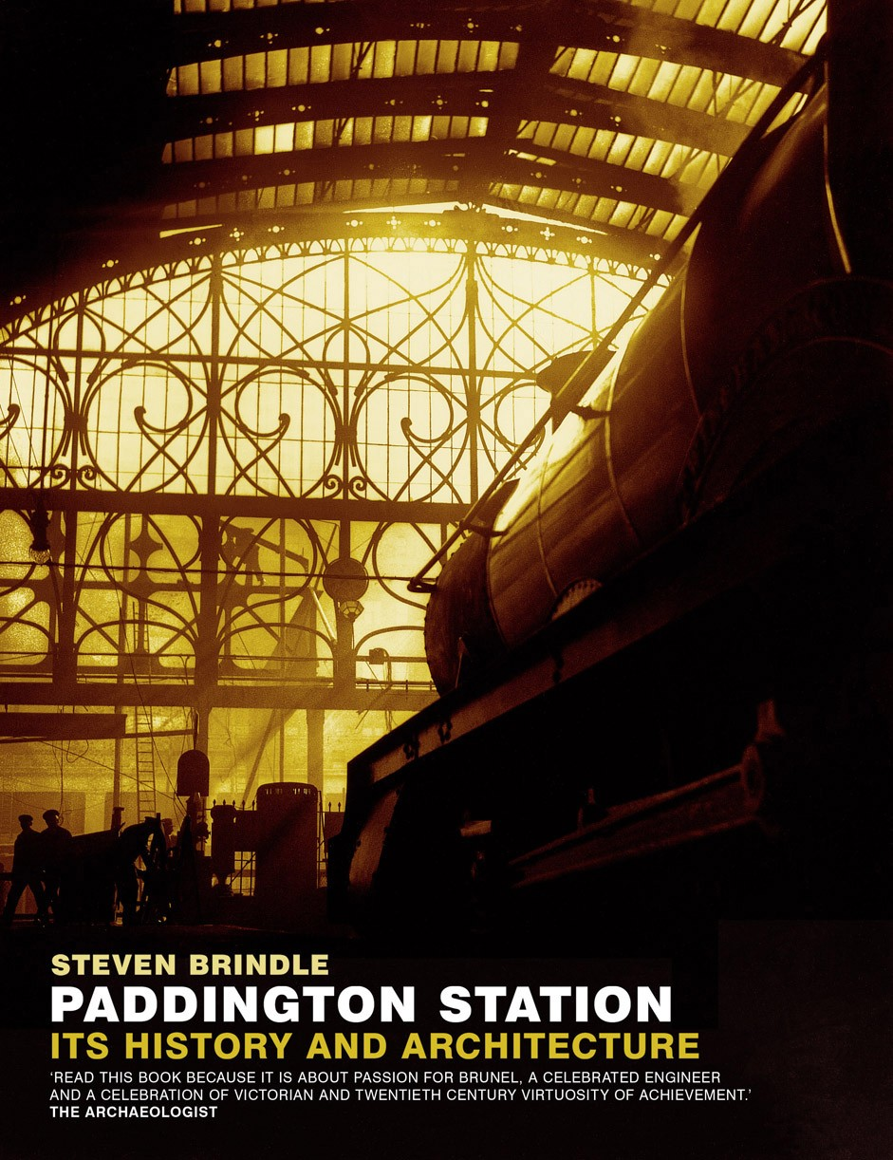
Author: Steven Brindle
Pub Date: April 2006
Price: £11.99
ISBN: 1 873592 957
Format: Paperback
Rights: EH
Territory: World
Extent: 174 pages
Category: History/Architecture
Key Sales Points:
- Shortlisted for the Alice Davis Hitchcock Medallion for best architectural book 2005
- April 2006 is the bicentenary of Brunel’s birth
- The definitive history of this iconic London station
- Illustrated with over 150 archive photographs, modern images and plans and drawings from Brunel’s sketch books
- Appeals to those interested in Brunel, railway enthusiasts and general reader

About the Book
“ Read this book because it is about passion for Brunel and a celebration of Victorian and twentieth-century virtuosity and achievement”
Robina McNeil, The Archaeologist

Paddington, the Great Western Railway and Isambard Kingdom Brunel are at the heart of railway history. Acknowledged by some as Brunel’s finest work, Paddington Station has a stature, an atmosphere of expectation and an air of romance not found in any other railway station. Approaching from the Underground below, you glimpse the arched roof high above you and as you ascend the whole tremendous interior reveals itself. Light floods the central span from the Lawn roof, and the delicate tracery at the far end is silhouetted.
The construction of Paddington Station and the building of the GWR have a place in world history. This history forms the background to this book, supported by pictures of Paddington Station down the decades including bomb damage during the Second World War, ladies protesting in the General Strike, and the Victorians perched on cornices to see royalty go by - are all utterly engrossing.
Brindle's narrative is detailed and colourful. The story encompasses the genius of Brunel, the rise and fall of the Great Western Railway, the sublime architecture, the social changes and the modern redevelopment of one of Britain's great landmarks.

