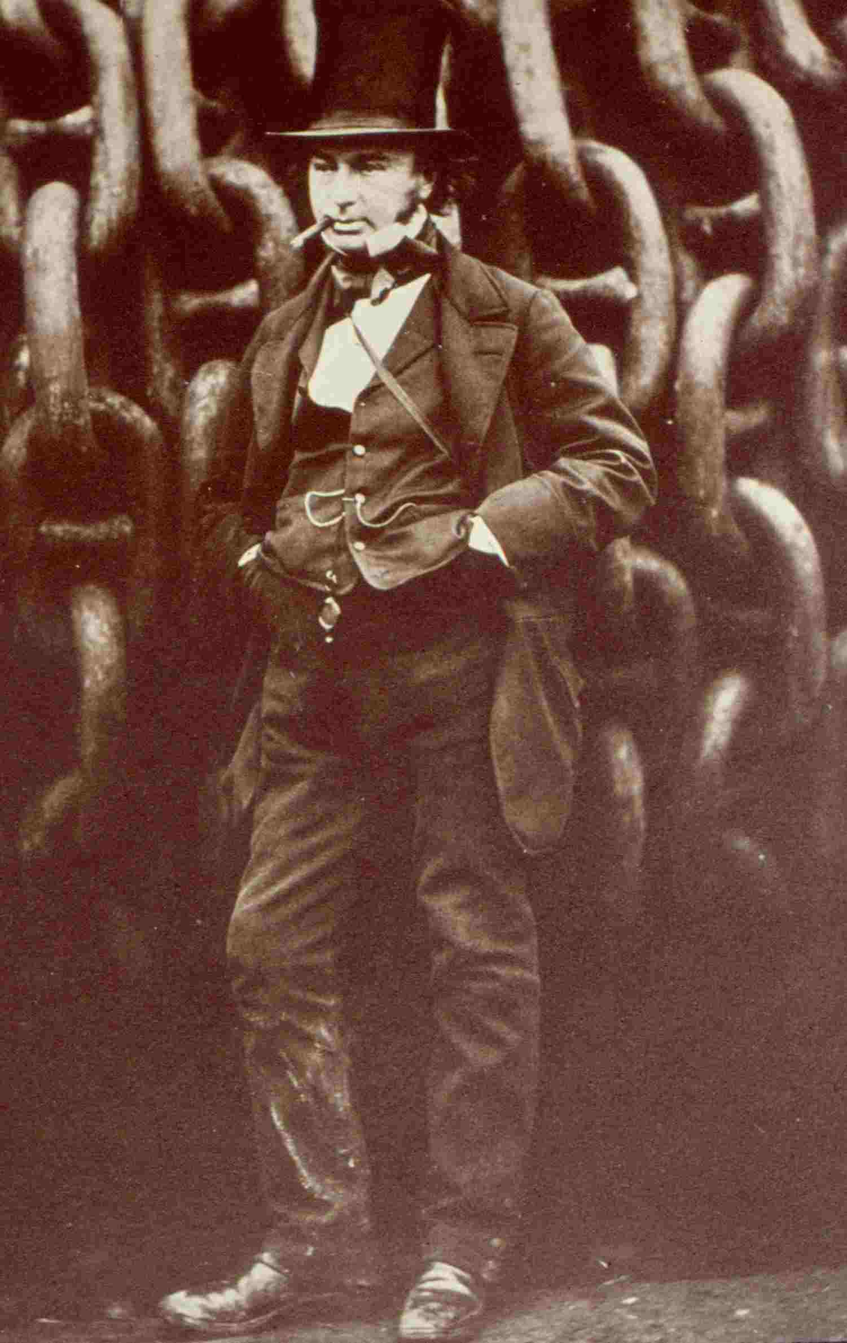


Brilliant Mr Brunel!

Brunel 200 touring science show for Key Stage 2
LMI Interactive (Richard Ellam, science communicator/engineer). Running time 45 mins (show can be repeated).

Summer term funded workshops for Bristol
LEA schools on a first come, first served basis,
dependent on availability.
………………………………………………………………………………………
Discover the simple science behind some of Isambard Brunel’s great feats of engineering. ‘Brilliant, Mr Brunel!’ explains how arches and suspension bridges stay up while carrying heavy loads, how Brunel’s knowledge of friction helped him to make the Great Western Railway the fastest in the world, and how some simple maths helped him to work out the way to make steamships travel further than ever before.
‘Brilliant Mr Brunel!’ is packed with live demonstrations and opportunities for audience participation, which explain some of the key challenges overcome by one of Britain’s greatest engineering geniuses.
Key Topics: structures; friction, forces and gravity; why things float; rules of proportion; how engineers solve problems.
Curriculum Links: Key Stage 2

Science: Unit 4E Friction, Unit 6E Forces in Action D&T Unit 6A, Shelters (structures)

Maths: Ma3: Shape, Space & Measure History: Unit 12 Life in Victorian times

Name of school:

Teacher contact and position:

Address:

Telephone:

Fax:

Email:

Number of pupils: Year:

Please give 3 potential dates May – July and state timeslots

What learning outcomes do you envisage from this opportunity?

Brilliant Mr Brunel!

Brunel 200 touring science show for Key Stage 3
LMI Interactive (Richard Ellam, science communicator/engineer). Running time 45 minutes
(show can be repeated)

Summer term funded workshops for Bristol
LEA schools on a first come, first served basis,
dependent on availability.
…………………………………………………………………………………………
Discover the simple science behind some of Isambard Brunel’s great feats of engineering. ‘Brilliant, Mr Brunel!’ explains how arches and suspension bridges stay up while carrying heavy loads, how Brunel’s knowledge of friction helped him to make the Great Western Railway the fastest in the world, and how some simple maths helped him to work out the way to make steamships travel further than ever before.
‘Brilliant Mr Brunel!’ is packed with live demonstrations and opportunities for audience participation, which explain some of the key challenges overcome by one of Britain’s greatest engineering geniuses.
Key Topics: structures; friction, forces and gravity; why things float; rules of proportion; how engineers solve problems.
Curriculum Links: Key Stage 3

Science 7K Forces and their effects, 9L Pressure and Moments
D&T : resistant materials, (structures)
Mathematics: Ma3: Shape, Space & Measure
History; Unit 11 Industrial changes

Name of school:

Teacher contact and position:

Address:

Telephone:

Fax:

Email:

Number of pupils: Year:

Please give 3 potential dates May – July and timeslots

What learning outcomes do you envisage from this opportunity?

