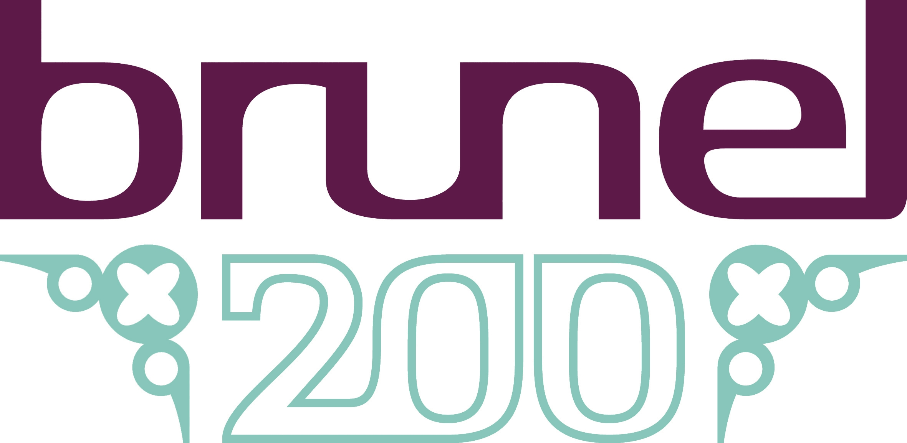
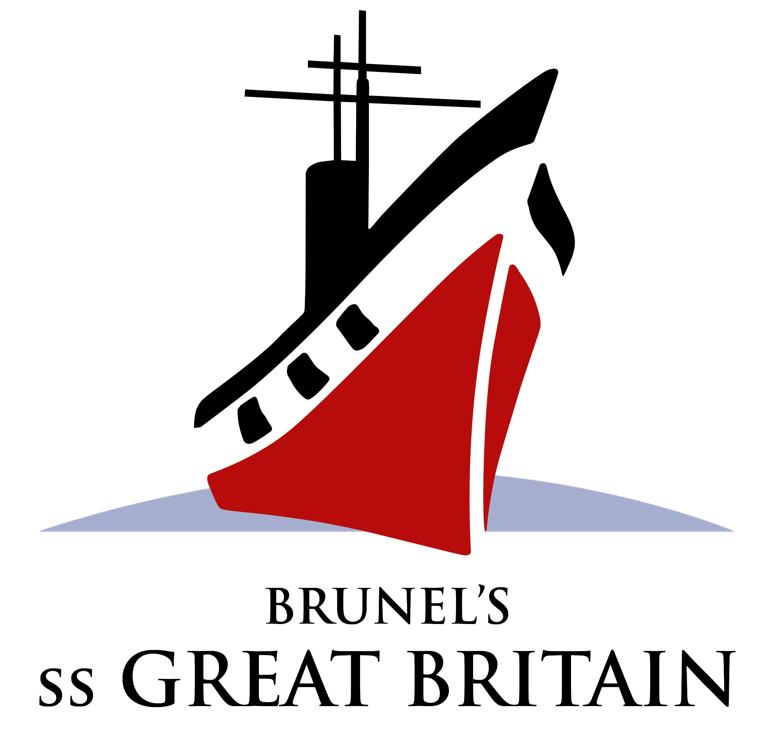

Brunel's ss Great Britain April – October 2006

The Nine Lives of Isambard Kingdom Brunel

A new exhibition in our refurbished exhibition centre specially created for the Brunel 200 celebrations.

Free to school children 16 years or below, one teacher per 10 children goes free. School groups but must be booked in advance.

The exhibition aims to:

- Bring to life Brunel’s experiences and achievements through his own words, eyes and responses, and those of his contemporaries and observers
- Discuss Brunel’s faults and failures as well as his strengths and successes;
- Showcase key Brunel artefacts including his drawings of the Suspension bridge and extracts from his diaries
- Link to Brunel 200 educational activities

The exhibition content will express the many challenges Brunel faced, the numerous risks he took and obstacles to his progress. Crises such as the Thames Tunnel incident, the railway gauge controversy and the Great Western accident will be explored. Brunel’s determination to make his projects succeed, his personal struggle and the price he paid will be highlighted.

Links to educational workshops (available from September only) including:

Victorians at Sea (KS1)
Explore the objects used by passengers on a voyage and dress up in character from First to Third Class. Discover and play with the toys and games that children would have known on the 60 day passage to Australia.

Brunel- our Engineering Hero (KS1)
Exploring the effect of Brunel’s engineering achievements on people’s everyday lives through comparing and contrasting travel before and after Brunel. Costumes and props for characters help ‘transport’ the children back in time and explore the character of Brunel.

Passenger Investigation (KS2 can be adapted to suit KS3)
Investigate artefacts, diary extracts and original documents to build up a picture of different people who travelled onboard, from first class to steerage passengers.

Special Brunel 200 projects:
To help celebrate Brunel 200 we will be running 2 new school projects, please contact Helen Horler, Education Officer on 9260680 to discuss your requirements.

Brunel Bridge Building Competition- for Secondary School Pupils (KS3) October

Do you want to enthuse and enlighten our engineers of the future? This is a cross curricular day where teams will compete against each other to see who can build the bridge that can hold the most weight but also find out why. Small Piece Trust are involving engineering ambassadors to deliver key elements of the sessions. Youngsters are asked to manage their project including a budget and use their presentation skills. A real challenge with lots of surprises in store including prizes!


Weekend and Holiday Events

‘Ask Brunel’
A fun family experience- come and talk to Brunel and ask him those questions you have been wanting to ask. Our talented actor brings to life all the enthusiasm of Brunel to show you the ‘Nine Lives of Isambard Kingdom Brunel’ exhibition and the ss Great Britain. Brunel is highly entertaining but also a fun learning tool. Entrance to the exhibition is free for children under 16 and Brunel will enhance your visit at no extra cost.

Holiday workshops (bookable):

Marvellous Moving Mechanisms
A ‘hands on’ experience where 7-11 year olds can design and create moving Victorian pictures on a zoetrope like the one in the Nine Lives of IK Brunel exhibition. They can create their own Victorian style working mechanism to take away. Marvellous Moving Mechanisms is an hourly workshop for 8 children and will run at 11.00 and 2.00 in the Medlock Education Centre. £6.00 per workshop plus admission.

Dates:
27th May 9th August
Both sessions have fully qualified and experienced staff. The summer holiday session will feature an automata expert to inspire and provide support in creating mechanisms.

Please contact Brunel’s ss Great Britain to make a booking, call the Education team on 0117 926 0680 there are limited places on both workshops so get ahead and book!

For further information about projects contact:
Helen Horler, the Education and Access Officer on 0117 9260680 or email enquiries@ssgreatbritain.org to discuss your workshops requirements.
And visit www.ssgreatbritain.org.

If you are ready to book a workshop, please call Administration Manager, Cathy Wrigley on 0117 9260680.

