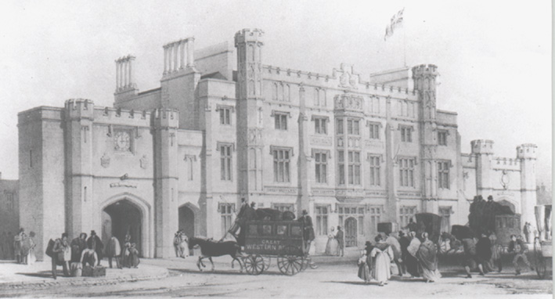
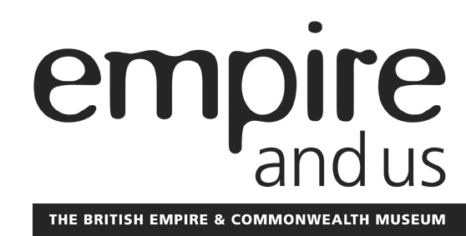
The British Empire & Commonwealth Museum is housed in the world’s first purpose-built railway station, designed by Isambard Kingdom Brunel. The Museum is offering a range of activities for all ages as part of the Brunel 200 celebrations during 2006.

KS2: Victorian Week, 6th – 10th March 2006
A full day event
Transport yourself back to the age of steam during our Victorian Week. Your visit will include a tour behind the scenes of the Museum - originally designed by Brunel as the world’s first purpose built railway station - artefact handling, costumed role-play, art and craft workshops, and much more. Cost - £4.50 per pupil.

KS2: Brunel’s Building
A two hour workshop
QCA; History Unit 18: What was it like to live here in the past?
This workshop features a site tour including areas of the building not usually seen by the public. In addition to the physical building itself, maps, plans, photographs and objects are all used to help the pupils investigate the original design and use of the building, how it operated, and the people and activities involved. Cost - £60 per class of 30 pupils

KS3: A Transport Revolution

A two hour workshop
QCA: History Unit 11: Industrial changes: action and reaction
Using the Brunel-designed Museum building as a resource, along with maps, photographs and plans, pupils will explore how the development of the railway at Temple Meads affected the lives of people living in Bristol during the 19th century. Cost - £60 per class of 30 pupils

GCSE and beyond: History Study Days

A full day event, book for any time during 2006
A day of talks, discussions and gallery visits about Brunel and Transport in Britain, c 1840-1900. These tailor-made sessions are designed for secondary and further education students and provide them with an opportunity to investigate topics, listen to oral history recordings and examine primary sources relevant to their course of study. Cost - £75 per group of 30 students

INSET Day: Brunel 200, Wednesday 18th January 2006
The British Empire & Commonwealth Museum has put together a fun and informative professional development day to help you make the most of this special year. The day will cover all aspects of the history of Brunel, his inventions and their effect upon the world, and include plenty of practical suggestions for work both in the Museum and in the classroom. £55 per person

For more information about any of these events please call 0117 925 4980
or email bookings@empiremuseum.co.uk

The British Empire & Commonwealth Museum
Station Approach, Temple Meads
Bristol, BS6 6LT RCH: 1097205

