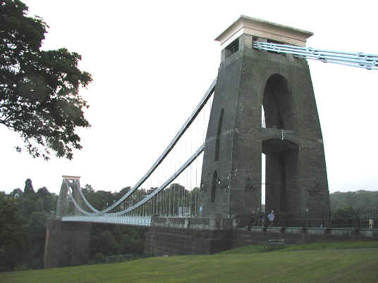

Year 8: Clifton Suspension Bridge

Name:…………………………………………………………...

Class:…………………………………………………………….

This workbook has been designed to use during the visit to Clifton Suspension Bridge and for follow up work during lessons after the visit back in the classroom.

The workbook is split into two sections as outlined below:

During the visit Page

Health & Safety Guidelines 2
Structures: Facts & Questions 3-5
Practical Activity (1) 6

The Tour 7

Post visit

Research project 8
Practical Activity (2) 9
Glossary 10

The Health and Safety Policy of Clifton Suspension Bridge is:

SAFETY FIRST AT ALL TIMES

Clifton Suspension Bridge operates in accordance with strict Health and Safety requirements. During site tours it is important that people comply with the following guidelines. These guidelines are issued to ensure the safety of everyone on the tour and also of the public around you.

- Pay close attention to any Health and Safety instructions that are issued by your tour guide.
- Always stay in your groups and stay close to your tour guide.
- Do not walk outside of the marked walkways.
- Pay close attention to warning signs and be aware of moving vehicles, etc.

In the event of fire during your visit your tour guide will take you to the nearest safe area. On leaving the site your tour guide will take you to a meeting point where you should remain as a group until instructed that it is safe to move on.

Structures are designed to carry loads and withstand forces without collapsing or falling over.

Structures include anything from electricity pylons to buildings, cars, lamp-posts and even thumbs.

Strong structures have to resist forces

Match the words in the box below to the appropriate force being applied to the shapes

1
2
3
1

5
4

Torsion Tension Shear Bending Compression

- What force is applied if a structure is being pulled in two opposite directions?
………………………………………………………….

A
B
C
D

- Look at this diagram above and answer the questions:
………………………
  - What kind of force are girders A & B resisting?
………………………
  - What kind of force is girder D resisting?
………………………
  - What kind of structure is this?
………………………
  - What’s the name for girders A & B?
………………………
  - What’s the name for girders C & D?

- What’s special about using triangles in a structure made of ties and struts?
………………………………………………………………………………………

- See if you can name the forces being applied in the picture below:

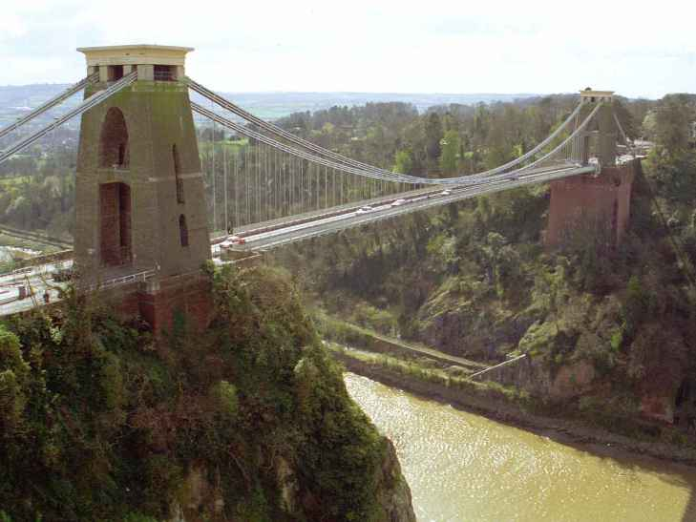

A
B
C

A –
………………………

B –
………………………

C –
………………………

There are two types of structures:
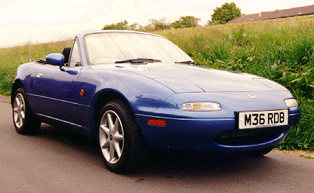
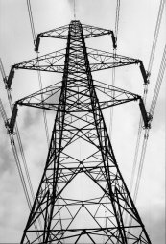
Sheet

and

Frame

Now fill in the blanks with the words provided to complete the following statements about structures:

Frame Structures

- A frame structure is a of ties and struts joined together. resist tension and resist compression.

- Examples of frame structures include and houses built around a wooden or steel frame.

- Often the frame is made up of because they are strong.

- Using triangle shapes in a structure is called .

Sheet Structures

- Also called .

- The structure is made up of or joined together.

- The way the pieces are put together is designed to make a , stable 3D shape.

- Examples include made of , or moulded plastic traffic cones.

Curved pieces Electricity pylons Triangulation Shell structures

Struts Car bodies 3D shape Ties Network Strong

Triangular shapes Metal panels Flat

Stability is a vital consideration for all structures. The structural principles behind stability can be demonstrated using frames built up from flat strips of Meccano, or similar flat strips of card.

Your guide will now provide you with a variety of simple square structures, made up from card strips held together loosely with pin-joints in each corner allowing movement (like the diagram below).

Investigate the possible movement in the structures using four and five strips by holding just one joint and applying slight pressure to one side.

Try again, using the structure with only 3 strips. What do you notice?

Now think about how you could strengthen the structures made from 4 and 5 member strips. What could you add to make sure no movement is possible.

Now you’re going on a tour round the suspension bridge. Listen carefully to the guide so you can answer the questions below.

- In which year did work on the piers (towers) begin?

- In which year was the Bridge completed?

- How high are the piers (towers)?

- What is the span of the Bridge between the two piers (towers)?

- Why is the Clifton side of the Bridge higher than the Leigh Woods side?

- What is the difference in height between the Clifton side and the Leigh Woods side?

- What are the dates of Brunel’s birth and death?

- How many chains are on each side of the Bridge?

- What is the Latin inscription at the top of the Leigh Woods pier (tower)?

- There are three major differences in the design and shape of the two piers. What are they?

Now you have learnt all about structures, forces and Brunel’s work on the Clifton Suspension Bridge, you need to design a presentation on another example of Brunel’s work.

Your presentation will be to the rest of the class and will use the following guidelines:

Your presentation should:

- Last no longer than 5 minutes
- Include handouts (if appropriate)
- Clearly explain the topic, in relation to structures
- Include some visuals (PowerPoint, OHPs, photographs, articles, etc)
- Include a question and answer session at the end

It’s easy to show the principle of a suspension bridge, this activity will get you to build one and show you how they work.

You will need:

  - 2 identical chairs
  - Strip of card about 9cm wide by 1 metre long
  - Two equal lengths of string
  - Fourteen shorter pieces of string for each side
  - Glue, sellotape, scissors
  - Toy cars

- Place the chairs back to back about a metre apart
- Rest the strip of card between the two chair seats
- Now try to put a load (toy car) on the bridge, what happens?

- Then, tie the two equal lengths of string parallel to each other to the chair backs
- Suspend the strip of card from the strings using the shorter lengths of string (use 7 for each side)
- What can the bridge carry now? Why?

